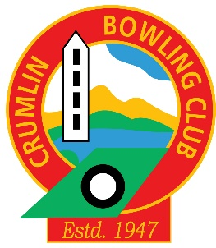
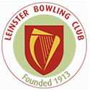

Leinster-Crumlin Open Bowling Tournament 2016

July 31st – August 7th 2016

June 2016

Hello All,

The Leinster /Crumlin tournament is again taking place culminating in a grand final and Monster Raffle in Crumlin Bowling Club on Sunday August 7th.

There are a variety ways you can get involved:

- First by entering the competition if this sounds scary find a friend and enter the Pairs.
Entry forms are on the various notice boards

- Second by buying a raffle ticket at €2 each or three for €5 – What a bargain!
Eugene and Vivien will be selling them

- Third by contribute a raffle prize. These can be left in the office or given to Vivien

- Fourth by helping out during the week of the tournament by marking matches.

- Fifth; Come and watch the matches at one or all of the various venues.
Leinster, Crumlin, CY, Kenilworth and St James’ Gate

There will be some great bowling on view and all free of charge

